**MENTOR MEDIA LTD**

**Freight Rates (FR)**

**Entity Relationship Diagram**

**IMPORTANT**

This information contain herein is the proprietary property of Mentor Media Ltd.

The holder agrees to the following:

1. Not to reproduce or copy it;
2. Not to reveal or publish it in whole or part;and
3. To maintain this document in confidence Framework & Standards

RELEASE HISTORY

|  |  |  |
| --- | --- | --- |
| Release No | Content | Effective Date |
| 1 | Create basic modules | 10 rd May 2021 |
|  |  |  |
|  |  |  |
|  |  |  |
|  |  |  |
|  |  |  |
|  |  |  |
|  |  |  |

|  |  |  |  |
| --- | --- | --- | --- |
| Prepared by | Thanh Trinh | Date | Sign |
| Designation | System Developer |
| Reviewed By |  | Date | Sign |
| Designation |  |
| Approved By |  | Date | Sign |
| Designation |  |
| Document No | Total no of the Pages (Excluding the cover page) : | | Release 1 |

Table of Contents

1. Database & Coding Standardization 4

1.1 View & Stored Procedure Naming Convention 4

1.2 View & Stored Procedure Revision Comment Format 4

1.3 Standard Message 5

2. Freight Rate 6

**2.1 MS_CARRIER** 6

**2.2 TR_COUNTRY_ZONE** 6

**2.3 TR_COUNTRY_ZONE_CHART** 7

**2.4 TR_CARRIER_ZONE** 7

**2.5 REF_COUNTRY** 7

2.6 TR_ SERVICE_TYPE 7

2.7 TR_CARRIER_ZONE 8

2.8 REF_PACKAGE_TYPE 8

2.9 TR_SERVICE_PACKAGE_TYPE 8

2.10 TR_WEIGHT_RATE 8

2.11 REF_SURCHARGE 9

3. Upload Price 10

3.1 TR_ SERVICE_TYPE 10

3.2 TR_CARRIER_ZONE 10

3.3 TR_TABLE_ONE_RATE 11

3.4 TR_TABLE_MULTIPLE_RATE 11

4. Other tables 12

REF_ACTIVITY 12

REF_COUNTRY 12

REF_AREA 12

MS_CONFIGURATION 12

# 1. Database & Coding Standardization

## 1.1 View & Stored Procedure Naming Convention

The name of view and stored procedure must follow as below:

|  |  |
| --- | --- |
| View Naming | Remarks |
| SV_REF_XXX | Base view for reference |
| SV_MS_XXX | Base view for master |
| SV_TR_XXX | Base view for transaction table |
| SV_XXX | View to be use in module |
| RV_XXX | View for report |

|  |  |
| --- | --- |
| Procedure Naming | Remarks |
| SP_WEB_[tablename] | Procedure for insert/update/delete purpose |
| SP_WEB_[tablename]_GET_XXX | Procedure for select purpose |
| RP_WEB_XXX | Procedure for report |
| FN_XXXX | Function for getting value |

## 1.2 View & Stored Procedure Revision Comment Format

* Every view and stored procedure must include the standard format below on the above  
  of the view/stored procedure name.
* Every change on the view/stored procedure must add a new version with edited date,  
  author name and the change description under revision history.
* 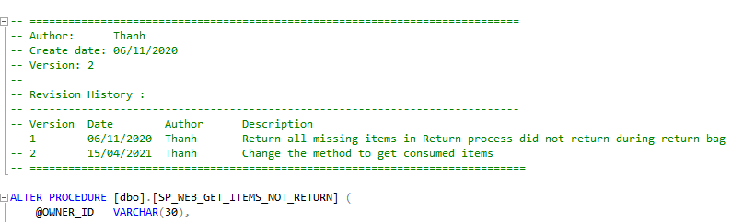The latest version must be updated at every change.

The latest version of this

view/store procedure

## 1.3 Standard Message

|  |  |  |
| --- | --- | --- |
| Module Name | Scenario | Message |
| General | No record found | No record found for %. |
| General | Mandatory field | This field is required. |
| General | Duplicated record | Duplicate record found for %. |
|  |  |  |
|  |  |  |
|  |  |  |
|  |  |  |
|  |  |  |

# 2. Calculator

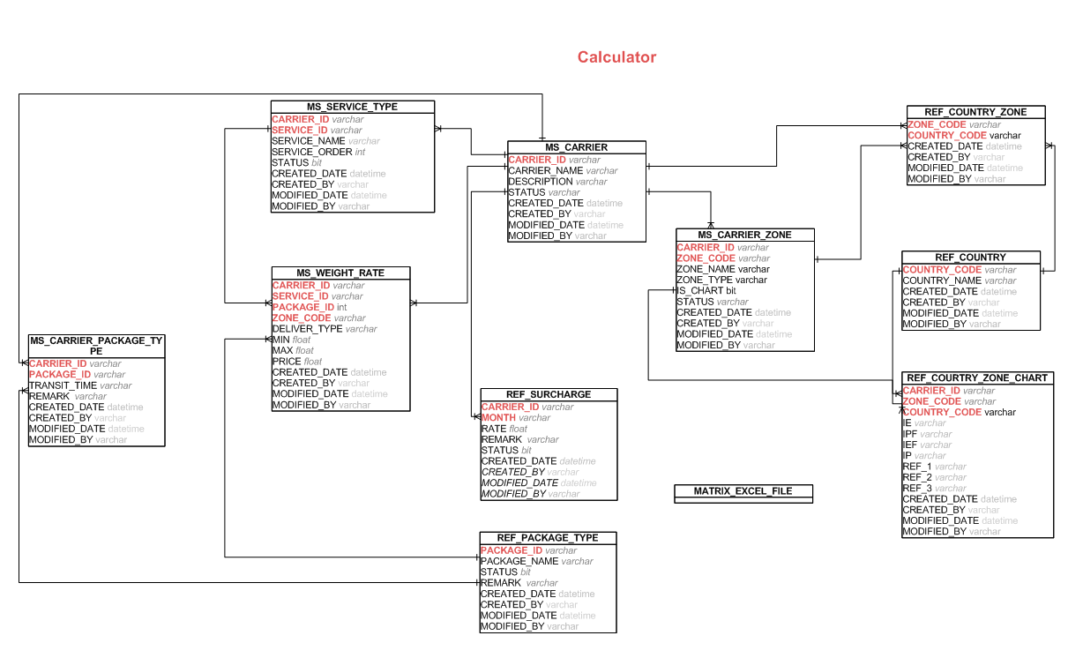

**2.1 MS_CARRIER**

This table keep every carrier in the system

|  |  |
| --- | --- |
| **Column Name** | **Description** |
| CARRIER_ID | The id of the carrier |
| CARRIER_NAME | The name of the carrier |
| DESCRIPTION | The short description of the carrier |
| STATUS | ACTIVE or OBS. The value refers to REF_STATUS_TYPE table with type CARRIER_STATUS. Default value is ACTIVE |

**2.2 REF_COUNTRY_ZONE**

This table keep a list of countries in a zone base on the carrier

|  |  |
| --- | --- |
| **Column Name** | **Description** |
| CARRIER_ID | The id of the carrier |
| ZONE_CODE | The code of the zone |
| COUNTRY_CODE | The code of the country |

**2.3 REF_COUNTRY_ZONE_CHART**

This table keep a list of chart character for FedEx carrier

|  |  |
| --- | --- |
| **Column Name** | **Description** |
| CARRIER_ID | The id of the carrier |
| ZONE_CODE | The code of zone |
| COUNTRY_CODE | The code of country |
| ***IE*** | ***Used for FedEx carrier*** |
| ***IP*** | ***Used for FedEx carrier*** |
| ***IPF*** | ***Used for FedEx carrier*** |
| ***IEF*** | ***Used for FedEx carrier*** |

**2.4 MS_CARRIER_ZONE**

This table keep a list of zone base on the carrier

|  |  |
| --- | --- |
| **Column Name** | **Description** |
| CARRIER_ID | The id of the carrier |
| ZONE_CODE | The code of zone |
| ZONE_NAME | The name of zone |
| ZONE_TYPE | The type of zone. |
| IS_CHART | 0 or 1. If the value is 1 so this meaning the zone has a table chart which need to enter by user. Default value is 0. |

**2.5 REF_COUNTRY**

|  |  |
| --- | --- |
| **Column Name** | **Description** |
| COUNTRY_CODE | The code of country |
| COUNTRY_NAME | The name of country |
| SHORT_NAME | The short name of the country |

## 2.6 MS_ SERVICE_TYPE

This table keep all list of service type of all carriers in the system.

|  |  |
| --- | --- |
| **Column Name** | **Description** |
| CARRIER_ID | The id of carrier. |
| SERVICE_ID | The id of the service. |
| SERVICE_NAME | The name of the service. |
| SERVICE_ORDER | The order of service. |
| STATUS | This Status of the service. It has Y/N value. Default value is Y |

## 2.7 REF_PACKAGE_TYPE

This table keep a list of package type

|  |  |
| --- | --- |
| **Column Name** | **Description** |
| PACKAGE_ID | The id of package type. |
| PAKCAGE_NAME | Type of package:Envelope(Doc), Pak, Package, NIL... |
| REMARK | The short description of the package type. |

## 2.8 MS_CARRIER_PACKAGE_TYPE

This table keep a list of type of package type base on the carrier

|  |  |
| --- | --- |
| **Column Name** | **Description** |
| CARRIER_ID | The id of the carrier |
| PACKAGE_ID | The id of package type. |
| TRANSIT_TIME | The transit lead time that counted by working days |
| REMARK | The short description of the package type. |

## 2.9 MS_WEIGHT_RATE

This table keep a list of price of the carrier base on the weight

|  |  |
| --- | --- |
| **Column Name** | **Description** |
| CARRIER_ID | The id of the carrier |
| ZONE_CODE | The code of zone |
| SERVICE_ID | Type of the service. It reference from **REF_SERVICE_TYPE** table |
| DELIVER_TYPE | The type of carrier's deliver. They are IMPORT, EXPORT, 3D PARTY. The value refers to REF_STATUS_TYPE table with type DELIEVER_TYPE. Default value is IMPORT |
| CARRIER_PACK_ID | The type of package base on the carrier. |
| MIN | Min weight value of product (start value of the range weight) |
| MAX | Max weight value of product (end value of the range weight) |
| PRICE | The price of this range weight |

## 2.10 REF_SURCHARGE

This table keep the option to input Surcharge for Freight rate computation

|  |  |
| --- | --- |
| **Column Name** | **Description** |
| CARRIER_ID | The id of the carrier |
| MONTH | The month of year that effect to price. |
| RATE | The rate value of the month |

**2.11 MATRIX_EXCEL_FILE**

The files are contained the zone matrix that look up to calculate the price of freight rate base on the carrier. It is external file which store in the server.

# 3. Upload Rate

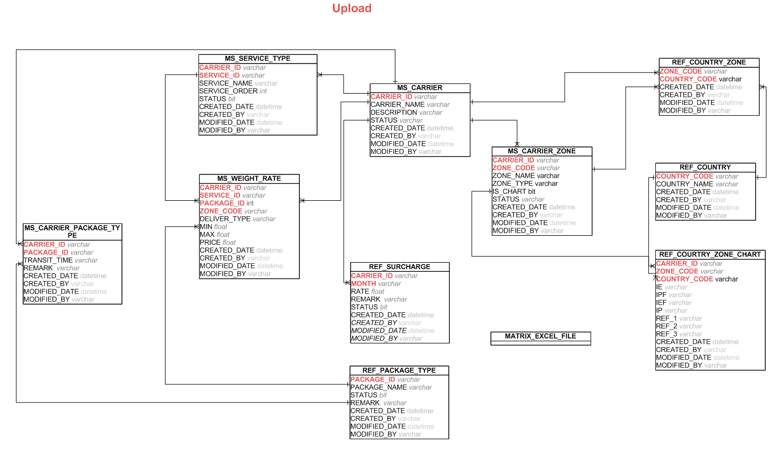

## 3.1 MS_ SERVICE_TYPE

This table keep all list of service type of all carriers in the system.

|  |  |
| --- | --- |
| **Column Name** | **Description** |
| CARRIER_ID | The id of carrier. |
| SERVICE_ID | The id of the service. |
| SERVICE_NAME | The name of the service. |
| SERVICE_ORDER | The order of service. |
| STATUS | This Status of the service. It has Y/N value. Default value is Y |

## 3.2 MS_CARRIER_ZONE

This table keep a list of zone base on the carrier

|  |  |
| --- | --- |
| **Column Name** | **Description** |
| CARRIER_ID | The id of the carrier |
| ZONE_CODE | The code of zone |
| ZONE_NAME | The name of zone |
| ZONE_TYPE | The type of zone. |
| IS_CHART | 0 or 1. If the value is 1 so this meaning the zone has a table chart which need to enter by user. Default value is 0. |

## 3.3 REF_PACKAGE_TYPE

This table keep a list of package type

|  |  |
| --- | --- |
| **Column Name** | **Description** |
| PACKAGE_ID | The id of package type. |
| PAKCAGE_NAME | Type of package:Envelope(Doc), Pak, Package, NIL... |
| REMARK | The short description of the package type. |

## 3.4 MS_CARRIER_PACKAGE_TYPE

This table keep a list of type of package type base on the carrier

|  |  |
| --- | --- |
| **Column Name** | **Description** |
| CARRIER_ID | The id of the carrier |
| PACKAGE_ID | The id of package type. |
| TRANSIT_TIME | The transit lead time that counted by working days |
| REMARK | The short description of the package type. |

## 3.5 MS_WEIGHT_RATE

This table keep a list of price of the carrier base on the weight

|  |  |
| --- | --- |
| **Column Name** | **Description** |
| CARRIER_ID | The id of the carrier |
| ZONE_CODE | The code of zone |
| SERVICE_ID | Type of the service. It reference from **REF_SERVICE_TYPE** table |
| DELIVER_TYPE | The type of carrier's deliver. They are IMPORT, EXPORT, 3D PARTY. The value refers to REF_STATUS_TYPE table with type DELIEVER_TYPE. Default value is IMPORT |
| CARRIER_PACK_ID | The type of package base on the carrier. |
| MIN | Min weight value of product (start value of the range weight) |
| MAX | Max weight value of product (end value of the range weight) |
| PRICE | The price of this range weight |

## 3.6 REF_SURCHARGE

This table keep the option to input Surcharge for Freight rate computation

|  |  |
| --- | --- |
| **Column Name** | **Description** |
| CARRIER_ID | The id of the carrier |
| MONTH | The month of year that effect to price. |
| RATE | The rate value of the month |

**3.7 MATRIX_EXCEL_FILE**

The files are contained the zone matrix that look up to calculate the price of freight rate base on the carrier. It is external file which store in the server.

# 4. Other tables

## REF_ACTIVITY

This table is a reference table for ACTIVITY_TYPE column in some table.

|  |  |
| --- | --- |
| **Column Name** | **Description** |
| ACTIVITY_TYPE | It is the code of the activity |
| DESCRIPTION | Describes the action needs to be taken by user/event |

## REF_COUNTRY

This tables keep a full list of the countries and used for ZONE reference.

## MS_USER

This tables keep all accounts which used to login the portal.

## MS_CONFIGURATION

This tables a list of parameters value and used for the system .